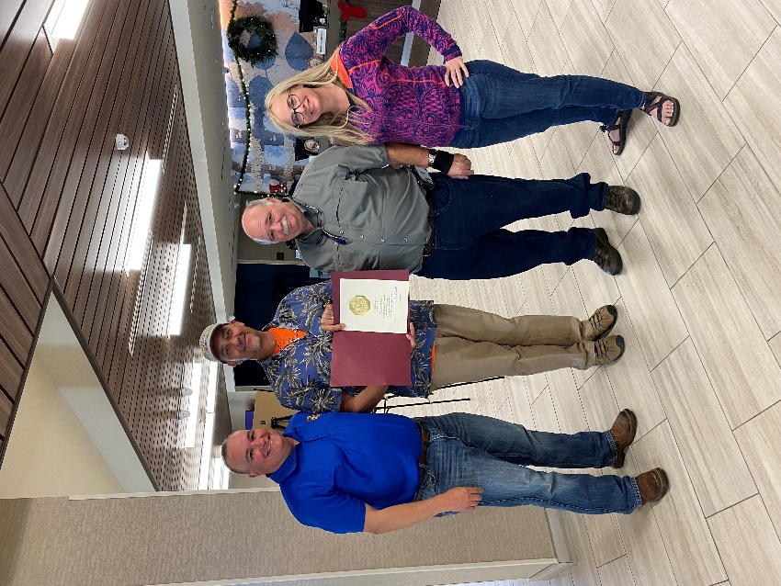

- Texas Mid-coast NWR Complex Project Leader Bryan Winton received his 30-year Certificate for collective federal service. Bryan has devoted a career in federal service working for US Fish and Wildlife Service (27 years), US Marine Corps (4 years), along with non-creditable service (Temporary/Seasonal work) with the National Marine Fisheries Service (3 years), US Geological Survey (2 years) and the National Park Service (4 mo). Bryan was presented his 30-year “pin” at the annual Region 2 Fire Management Program Meeting on November 16 in the Rio Grande Valley by fellow Project Leader Tim Cooper with Chenier Plains NWRC and others on the upper Texas Coastal Zone Leadership Team (Joe Saenz, Aransas & Matagorda Island NWRC, and Kelly Purkey, Balcones Canyonlands NWR).

